

Installation Manual
For 64 bit Windows Server 2012

Copyright and Disclaimer

COPYRIGHT NOTICE
Copyright © 2015 Educomp Smartclass
All rights reserved
Documentation version 1.0
Any technical documentation that is made available by Educomp smartclass is the copyrighted work of Educomp Solutions Limited and is owned by Educomp Solutions Limited.

DISCLAIMER.
This technical documentation is being delivered to you AS-IS and Educomp Solutions Limited makes no warranty as to its accuracy or use. Any use of the technical documentation or the information contained therein is at the risk of the user. Documentation may contain technical or other inaccuracies or typographical errors. Educomp Solutions Limited, reserves the right to make changes without prior notice.
No part of this publication may be copied without the express written permission of Educomp Solutions Limited

TRADEMARKS
Educomp smartclass is a trademark of Educomp Solutions Limited.

Table of Contents

Minimum System Requirements 4
Pre-requisite Software 4
Server’s Folder Structure 5
Step1: Install Internet Information Services IIS 6
Step 2: Install SQL Express 2008 with Advance Services 9
Step 3: Check\Start Full Text Services 17
Step 4: Key Generation 21
Step 5: Licence Request 22
Step 6: Install Shockwave 23
Step 7: Installation of Flash Player 11.2 24
Step 8: Installation of Microsoft Report Viewer 24
Step 9: Installation of Smartclass CTS 25
Step 9: Installation of Adobe AIR Installer 3.2 29
Step 10: Install Smartclass CTS. 30
Step 11: Configure Smartclass CTS. 30

Introduction

This document describes how to install and get started with the Educomp Smartclass system.

Minimum System Requirements

Microsoft windows Server 2012
Processor: Xeon 3.1 GHz
RAM: 4 GB

Pre-requisite Software

The Pre-requisite Software are in your server (\Softwares)
S.No | Application\Software | Version\type
1 | Internet Information Services(IIS) | 8
2 | SQL Express | 2008 with Advance Services
3 | Authkey Generator.exe | Latest(put version number)
4 | Internet Explorer | 8.0 or above for Win server 2012
5 | Windows Media Player | 11
6 | Adobe Shockwave Player | 11
7 | dot net framework | 3.5 and 4.5
8 | Flash Player | 11
9 | Java
10 | Hindi Font | Mangal.TTF & K010.TTF

Server’s Folder Structure

HDD | Drive | Folders
HDD 1 | C : | OS
 | D : | 1. SmartclassWeb
 |  | 2. SmartClassCTS Software & Utilites
 |  | 3. Shared
 |  | 3.1 Files
 |  | 3.2 Licencs
 |  | 3.3 SAS Images
 |  | 3.4 Free Text Images
 |  | 4 Contents
 |  | 5 Contents23
 |  | 6 MathGuruContents
 |  | 7 CDSContents

Step1: Install Internet Information Services IIS

Check for the availability of IIS on your Windows 2012 server.
- Click on Server Manager.

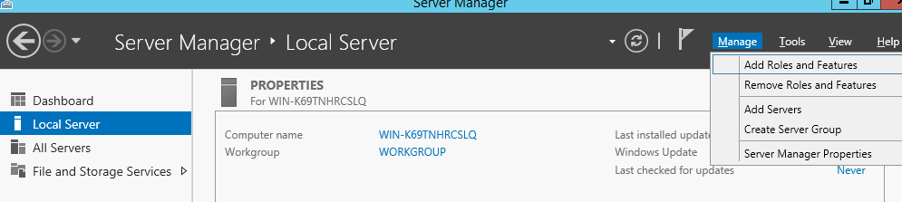
- The above screen appears. Click on Manage.
- Click on Add roles and Features and click next till you see the screen below.
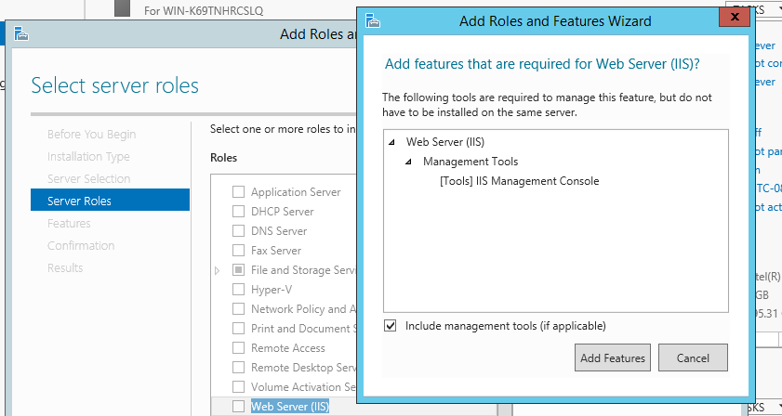
- The above screen appears. Tick the checkbox against Web Services (IIS) and click on add features button.
- Click on Next.
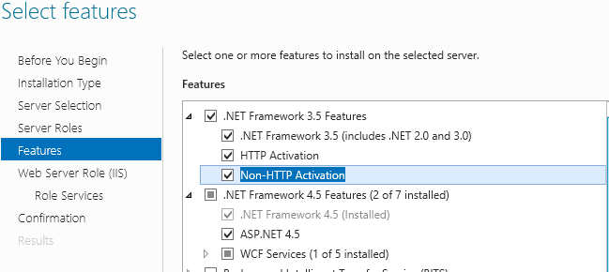
- The above screen appears. Add only necessary Role Services. Tick the checkbox against the following services and click on Next.
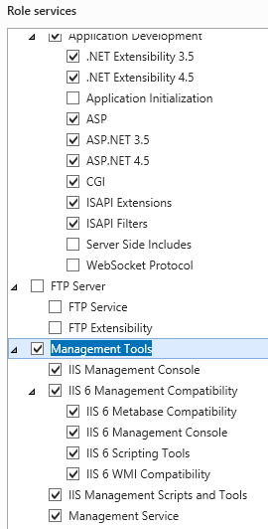
- The above screen appears. Add only necessary Role Services. Tick the checkbox against the following services (some of them may be already ticked) and click on Next. (on some steps, you may encounter window with a ‘add required features’ just click on the button) and click on install.
Common HTTP Features (By Default)
Static Content
Default Document
Directory Browsing
HTTP Errors
HTTP Redirection
Application Development Features
ASP.NET 3.5
ASP.NET 4.5
.NET Extensibility 3.5
.NET Extensibility 4.5
ASP
CGI
ISAPI Extensions
ISAPI Filters
Health and Diagnostics Features
HTTP Logging
Logging Tools
Security Features
Request Filtering
Management Tools
IIS Management Console
IIS Management Scripts and Tools
Management Service
IIS 6.0 Management Compatibility
IIS Metabase Compatibility
IIS 6 WMI Compatibility
IIS 6 Scripting Tools
IIS 6 Management Console

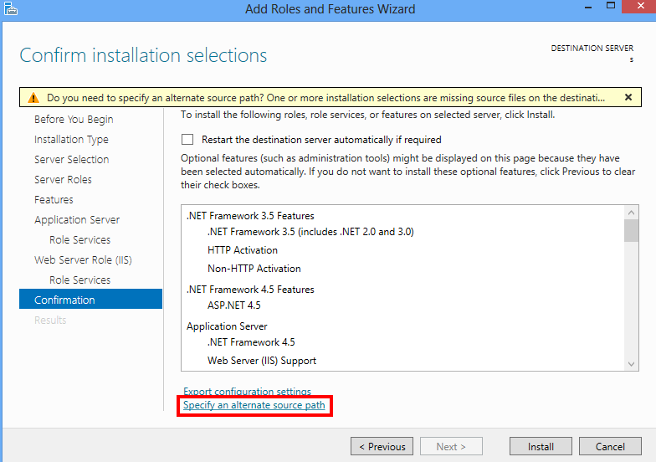

- Please click on ‘Specify an Alternate source Path’. on the next screen you need to give path of the CD drive as <driveLetter>\sources\sxs and click on OK button on the next two screens.
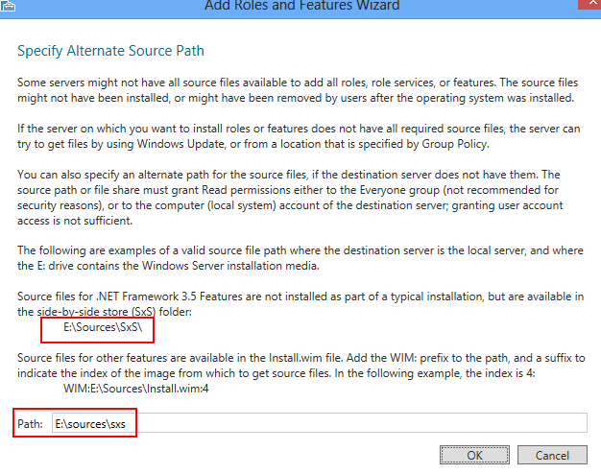
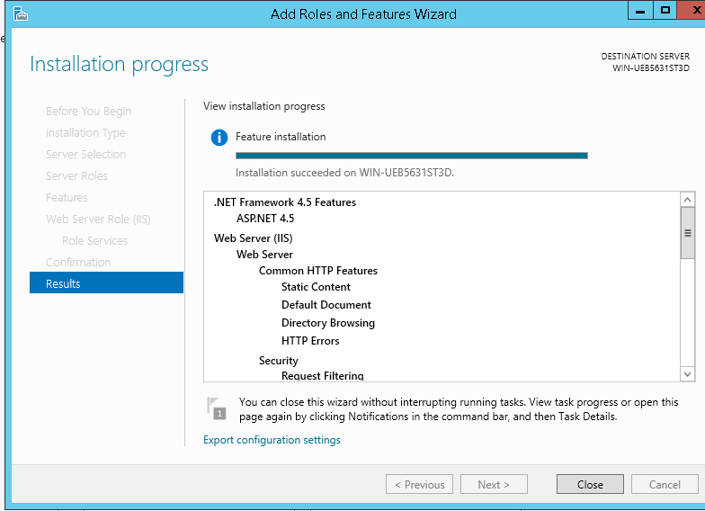

- Click on INSTALL button, Click on Close when process is completed.

Step 2: Install SQL Express 2008 with Advance Services
Note: During SQL Express 2008, please restart server once, and you may face ‘program compatibility’, just click on ignore button and continue installation.

- Install SQL Express 2008 with Advance Services
- Click on SQLEXPRADV_x86_ENU.exe to run the setup. The following screen will appear.
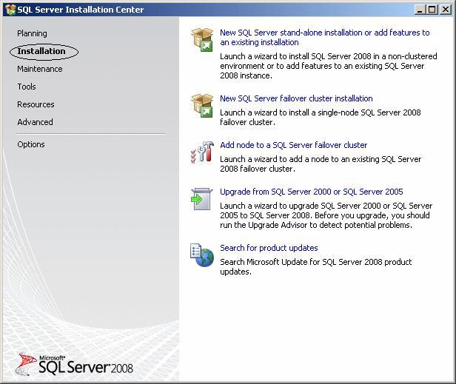
- Select Installation from the left section.
- On the right section, select New SQL Server stand-alone installation or add features to an existing installation.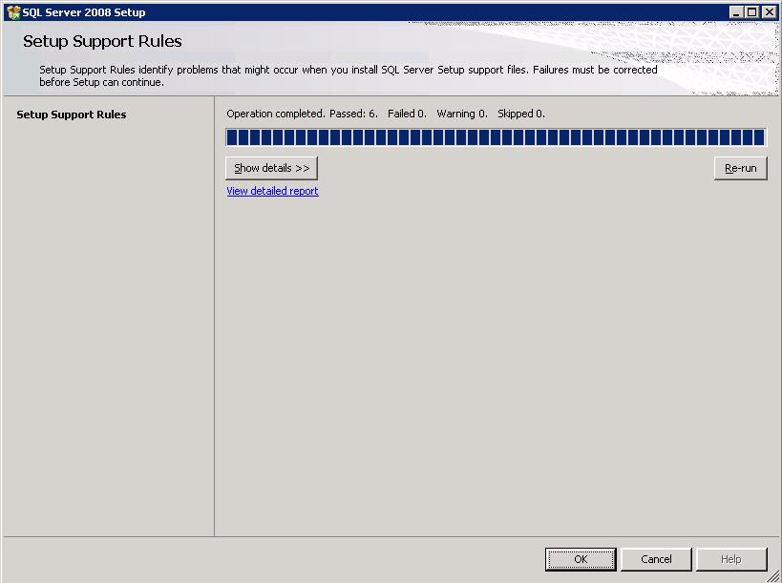
- Click on OK. The following window will appear.
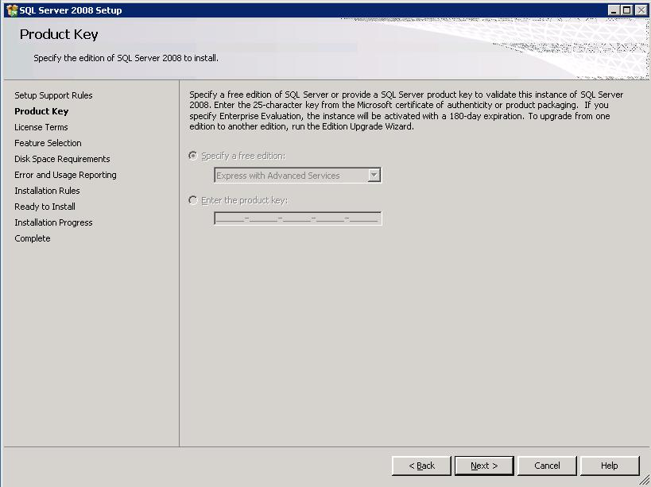
- Click on Next to proceed.

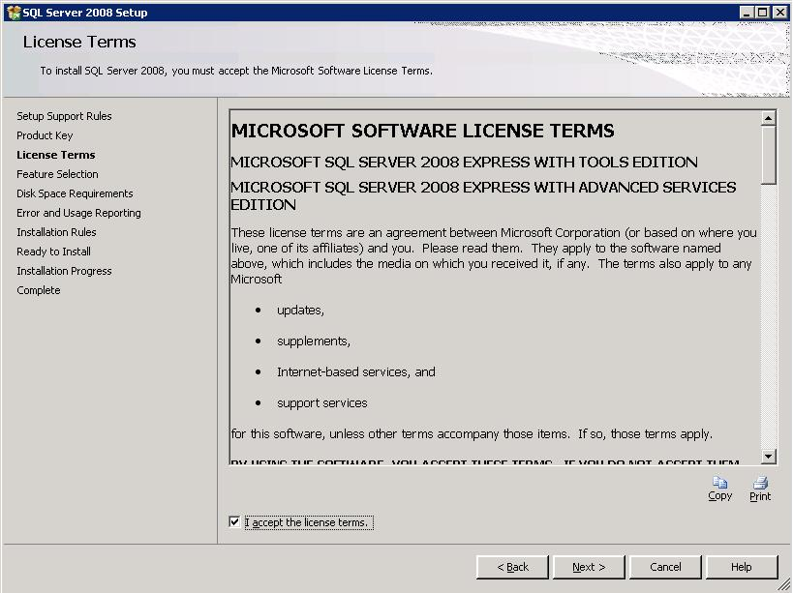
- Tick I accept the licence terms button. Click on Next.
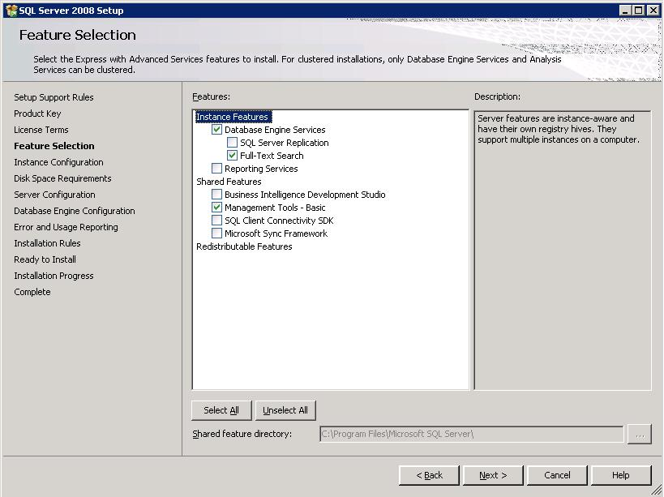
- The above screen allows you to install your preferred features. Select Database Engine Services, Full Text Search and Management Tools- Basic only.
- Click on Next to proceed.
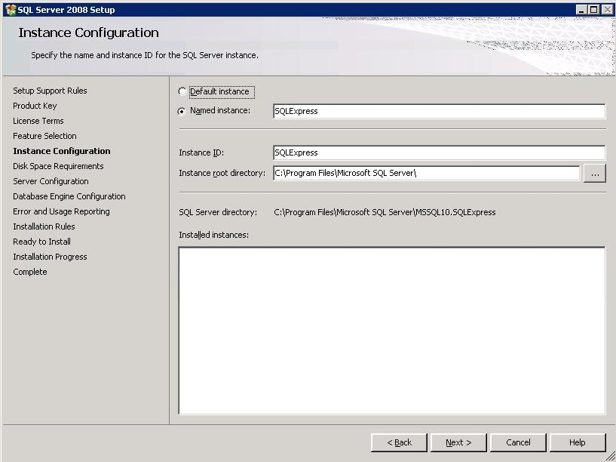
- The above screen allows you to name the instance and to specify the path of server installation. Select Named instance (it should always be SQLExpress), then click on NEXT

.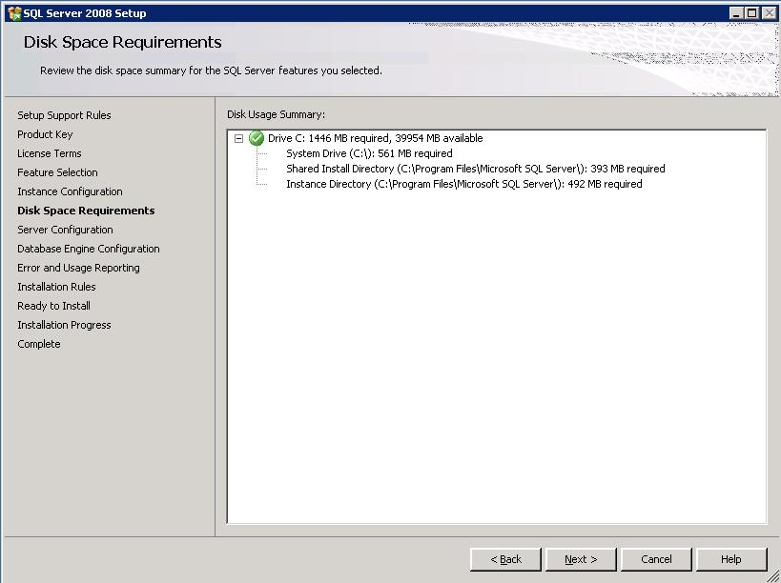

- The above screen allows you to check and confirm the disk space. Click on Next.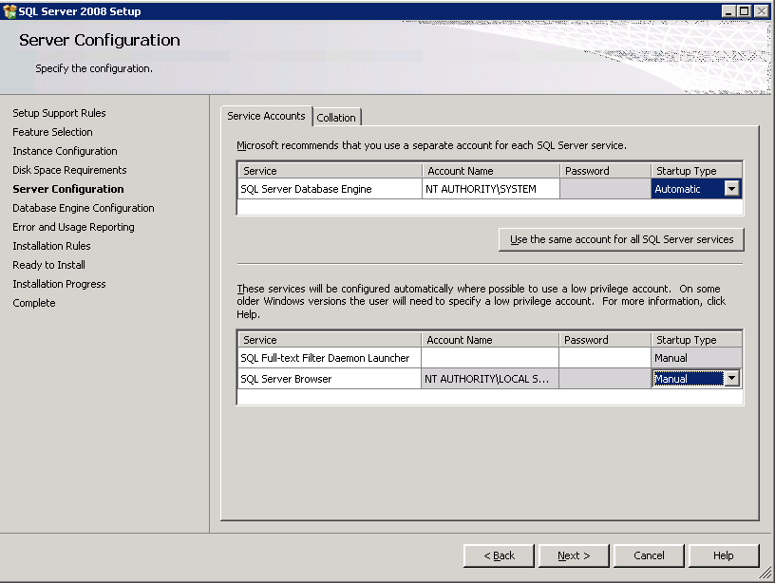
- The above screen allows you to configure the server. Make the selections as shown in the image above. Click on Next.
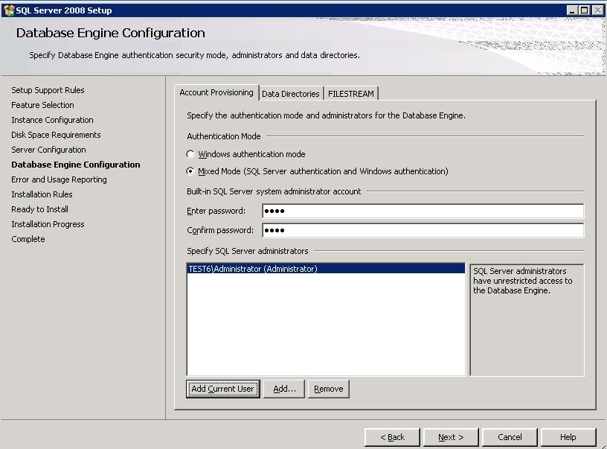
- The above screen allows you to specify the mode of authentication of the server.
- Select Mixed Mode (SQL Server authentication and Windows authentication)
- In the Enter password: field type sa@1
- In the Confirm password: field type sa@1
- Click on Add Current User.
- Click on Next.
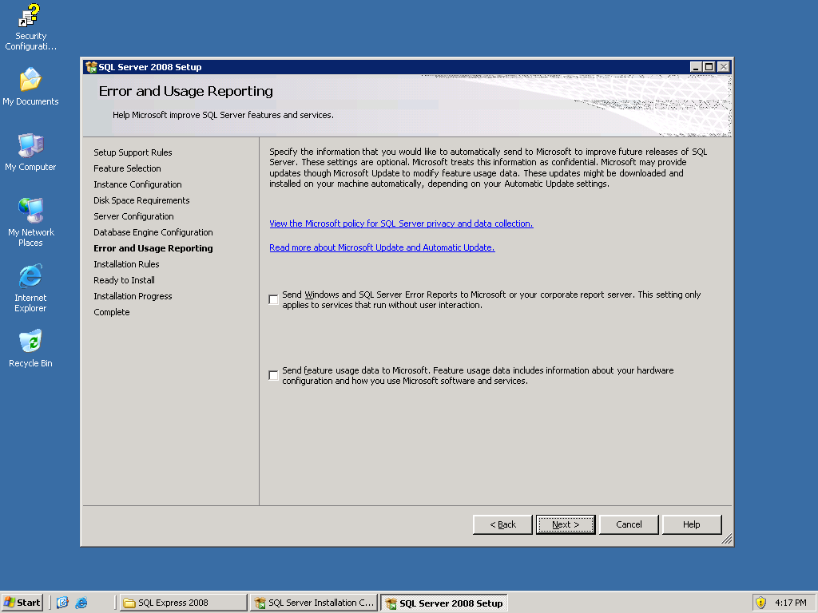
- Click on Next.
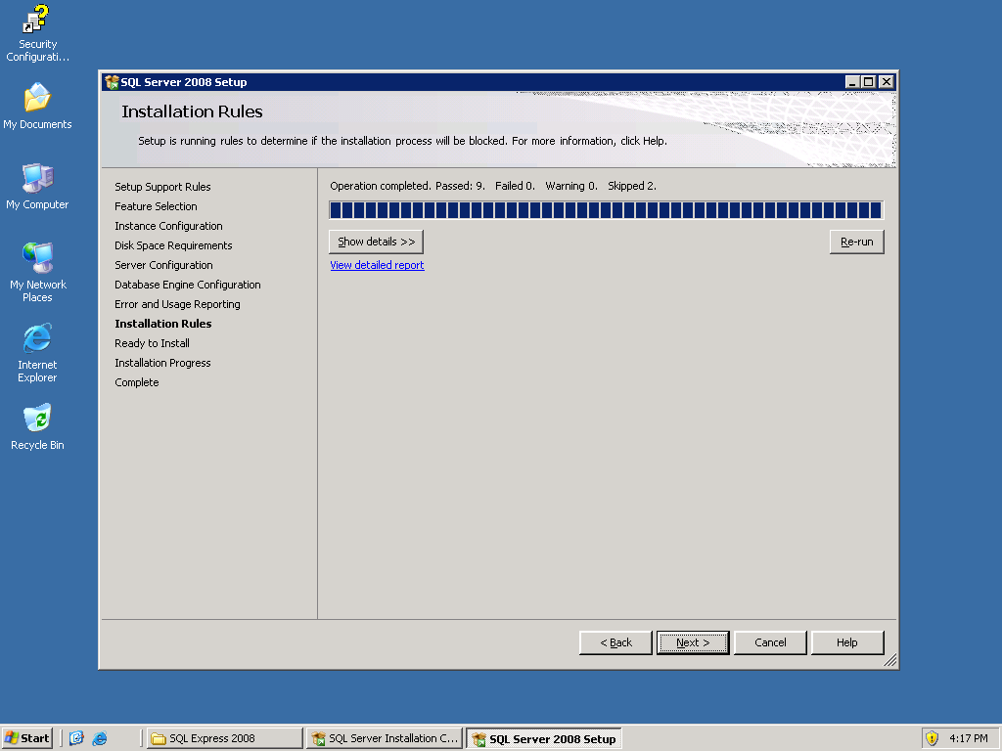
The above screen shows pre-installation.
- Click on Next.
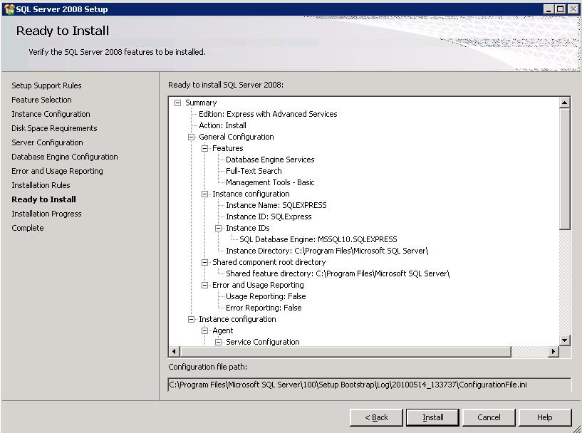
- Click on Install.
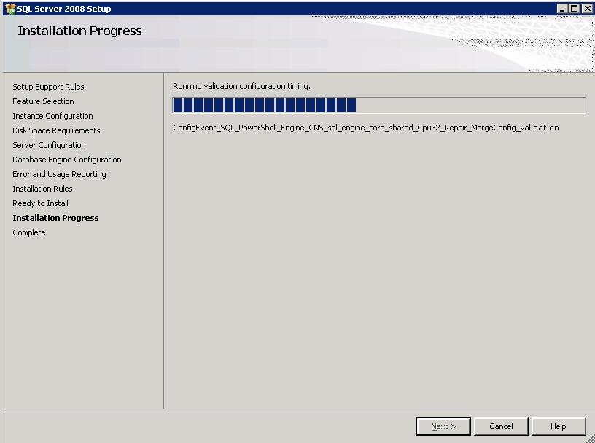
The above screen shows installation in progress.
- After the installation is complete, click on Next to proceed.
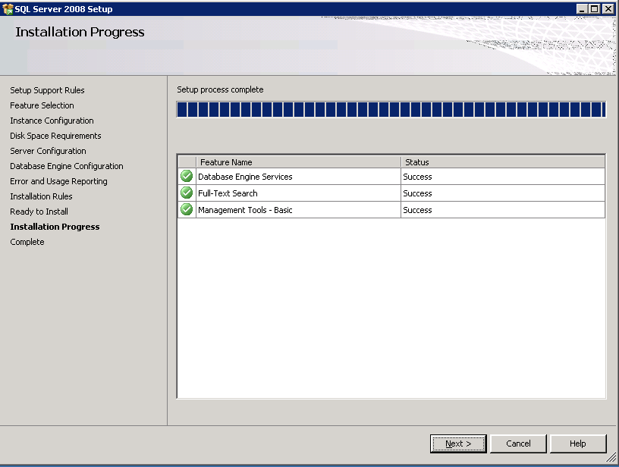
- Click on Next.
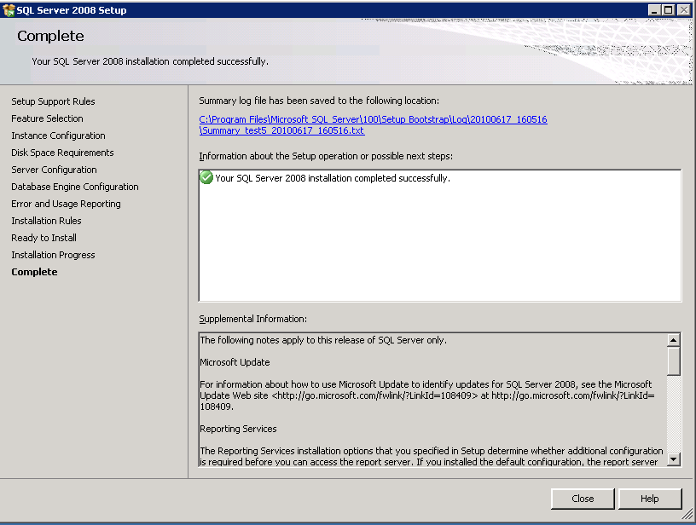

Step 3: Check\Start Full Text Services
Check if Full Text Services is started. Follow the Steps for checking\starting the Full Text Services as shown in diagram below.
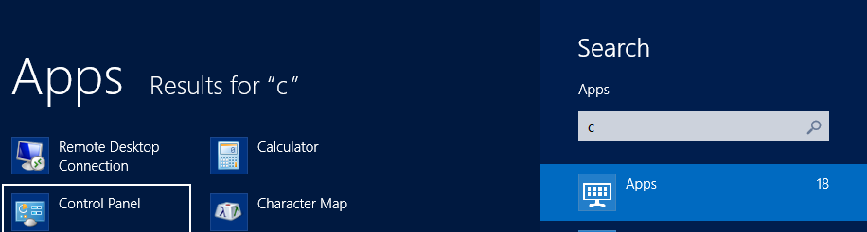




- Go to Control Panel
- Choose Administrative Tools
- Choose and Click on Services.
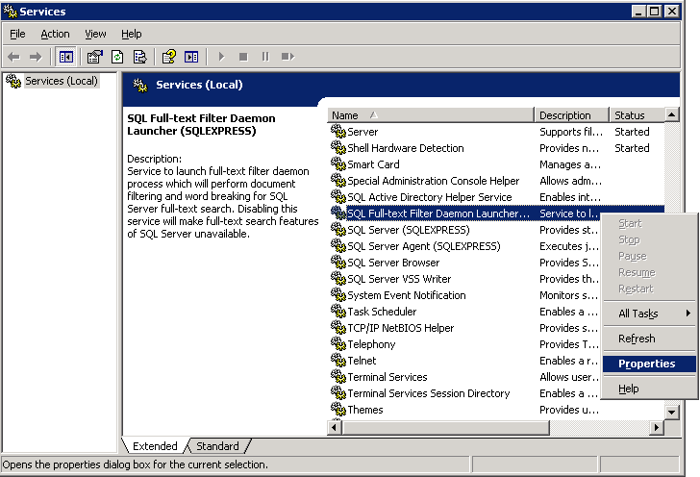
- Check the SQL Full –text Filter Daemon Launcher (SQLEXPRESS) status. If it is blank then Right Click on it and select Properties.
- 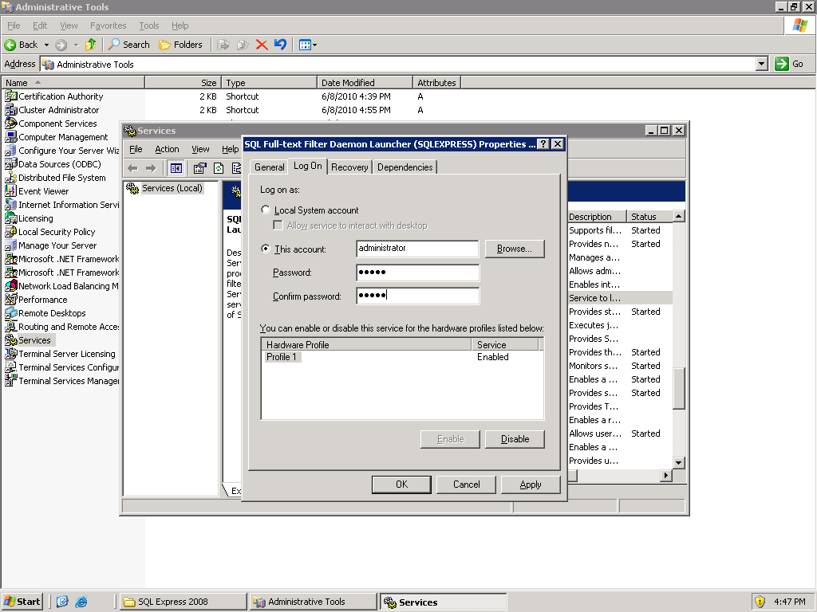
- Select Logon and select This account. Write down the server login name in the This account field and your server password in the Password and Confirm Password field.
- Click on Ok.
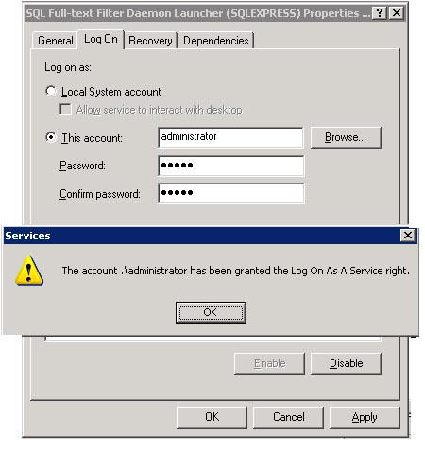
The above screen appears after clicking on Ok.
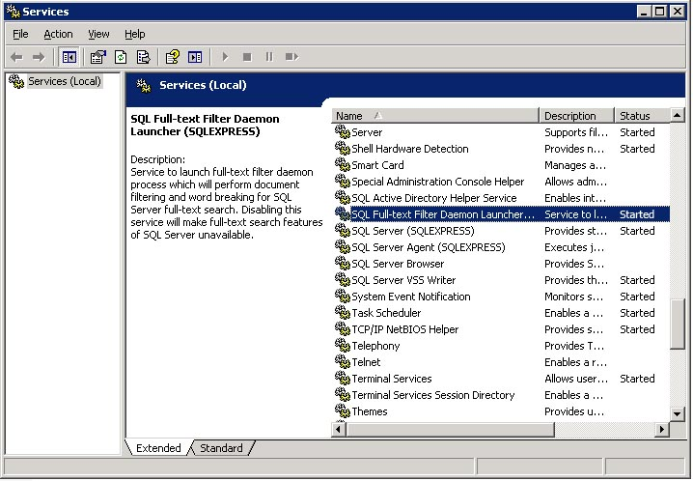
Figure 1 : The above screen shows SQL Full –text Filter Daemon Launcher (SQLEXPRESS) status as Started.
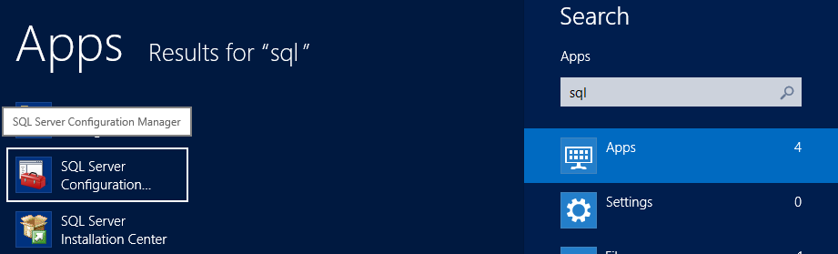
The above screen shows the steps to start the Full text Services from SQL Server Configuration Manager.
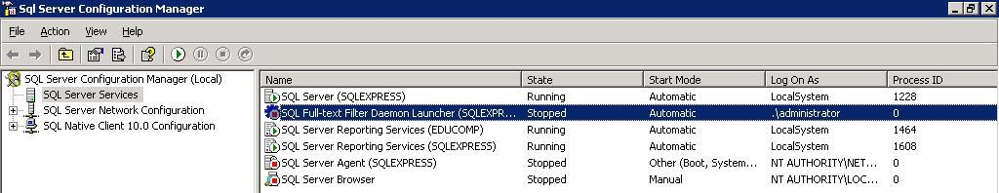
The above screen appears after clicking on SQL Server Configuration Manager.
- Select SQL Full –text Filter Daemon Launcher (SQLEXPRESS)
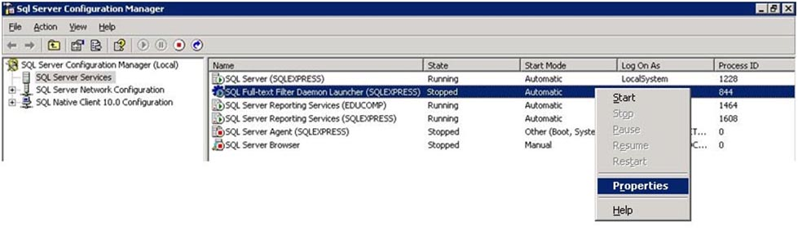
- Right click on SQL Full –text Filter Daemon Launcher (SQLEXPRESS) and select Properties.
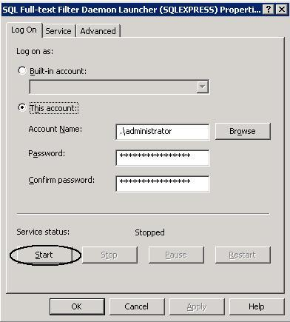
The above screen appears after selecting Properties.
- Select Logon and select This account. Write down the server login name in the Account Name: field and your server password in the Password and Confirm Password field.
- Open sql server configuration manager from the program list.
- The screen below shows SQL Full –text Filter Daemon Launcher (SQLEXPRESS) status as Running.
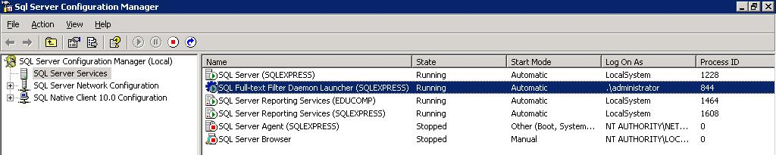

Step 4: Key Generation
 | Before starting with this step, please ensure that no external device (Hard disk\pen drive\data card) should be connected to the server.

- Create a folder called “Temp” in your C drive
- Browse \Softwares\AuthKey
- Double click on GenerateEducompAuthKey.exe
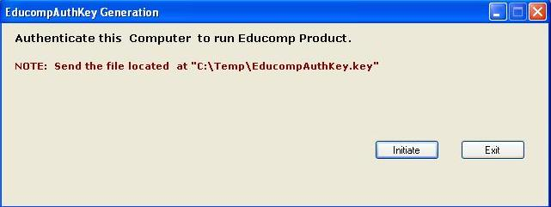
- The above screen appears. Click on Initiate.
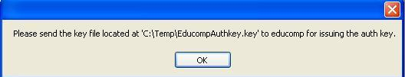
- Click on Ok. The key is saved in C\Temp.
- Click on Exit.

Step 5: Licence Request

- Mail the educompauthkey.key file generated in c:\temp to licence.smartclass@educomp.com , keep all the other stakeholders in CC.
- You will receive the Smartclass Licence in a ZIP file from support team’s side.
- Place the licence ZIP file at a location that can be located easily.
Reset IIS before proceeding to the next step.

- Go to Sidebar and click on search icon.
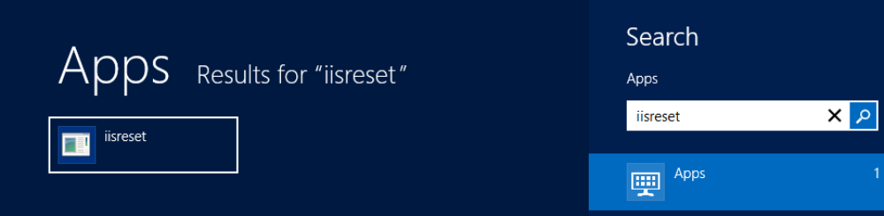
- Type <iisreset> in the box and then run the same.
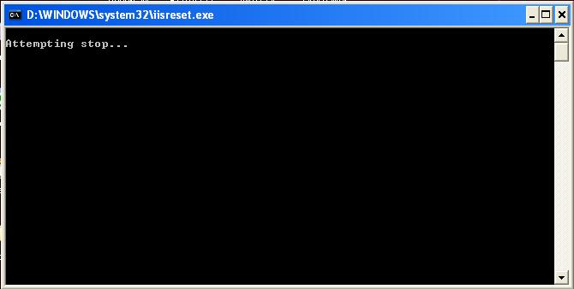
- IIS will stop and restart automatically.

Step 6: Install Shockwave
- Install Shockwave from Softwares\ Shockwave Player
- Click on Shockwave_Installer_Full.exe.
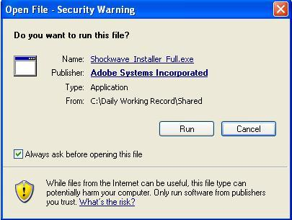
- Click on Run to start the installation.
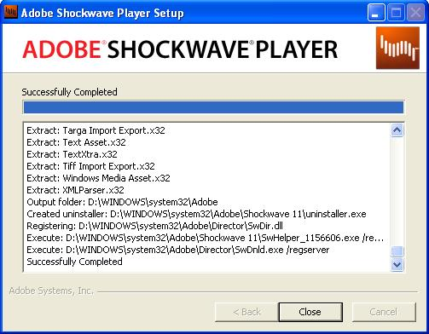
- Click on the Close Button. Shockwave installation is complete.

Step 7: Installation of Flash Player 11.2
Install Flash Player from Supporting Software Folder.
1. Double click on flashplayer_11.2.
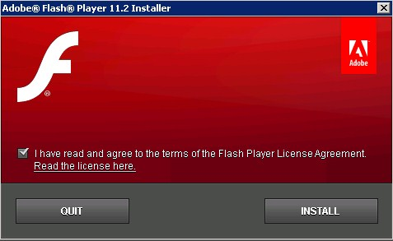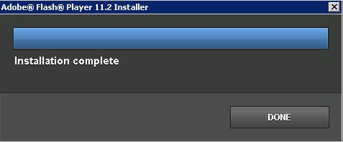

2
.

Sele
ct the License Agreement and click on Install Button.

3. Click on Done Button.

Step 8: Installation of Microsoft Report Viewer

Install report viewer from supporting software.

Step 9: Installation of Smartclass CTS

- Go to Sidebar and click on search icon.
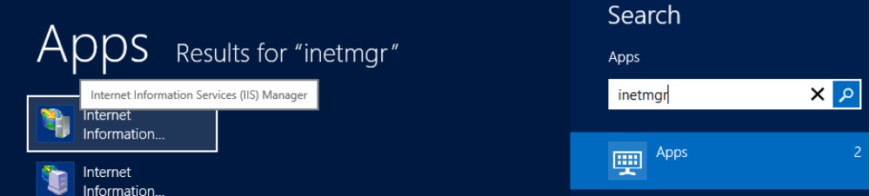
Type ‘inetmgr’ in the box and then run the same.
- Stop the Default Web Site before starting with the Smartclass setup.
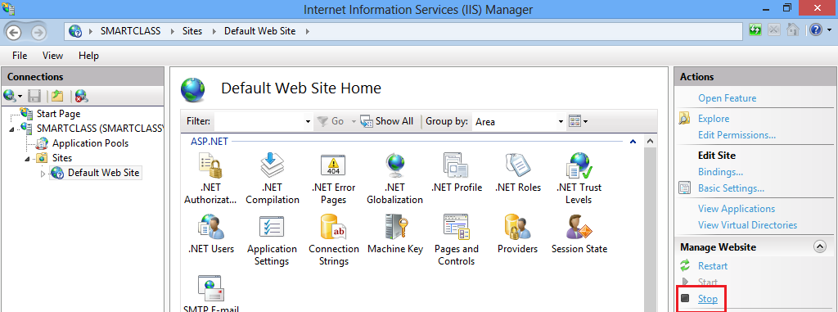
- Select Default Web Site and click on Stop.
- Run Smartclass setup Utility from ..\Supporting Software & Utility\SmartClassCTS Setup Utility-Special.
- Right Click on SmartClassSetupTool.exe and select ‘run as administrator to run the setup.
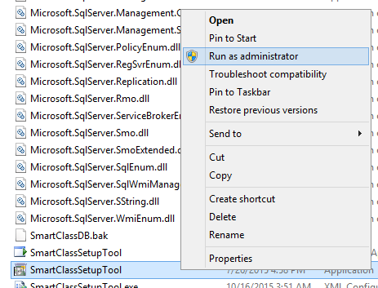
On the following screen, click on next button.
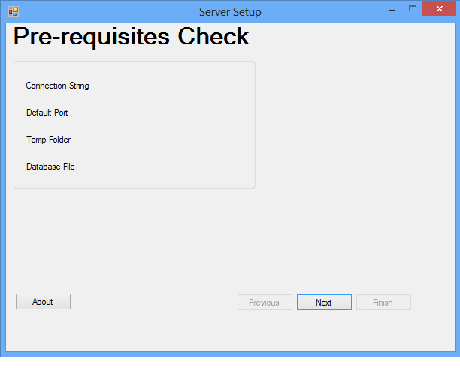
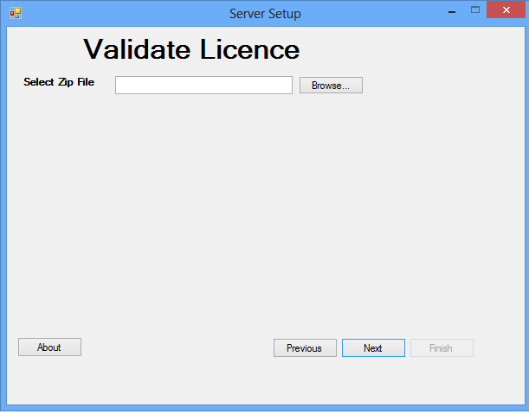
- The above screen appears after running the setup. Browse the zip file which you received from support team.
. 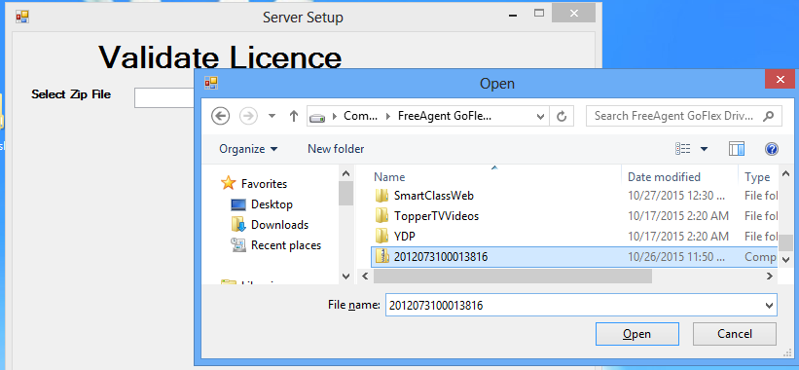
- Click on Next after browsing the zip file.
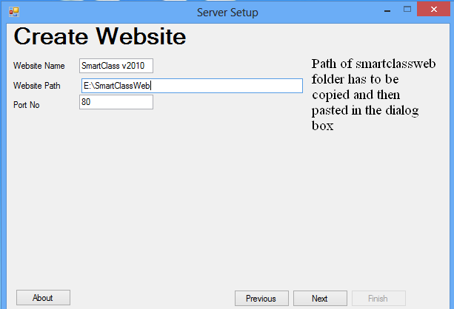
- The above screen opens after clicking on Next. Write the Website Path (..\Application\SmartClassWeb) and Port No (80).Click on Next.
Note: | The default Port Number is 80. The above step will set the complete website in IIS Including MIME types settings. There is no need to change other values.
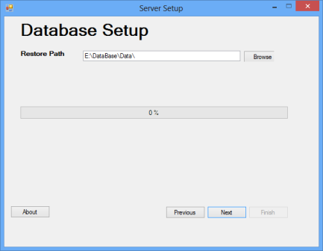
- Do not make any changes, click on Next.
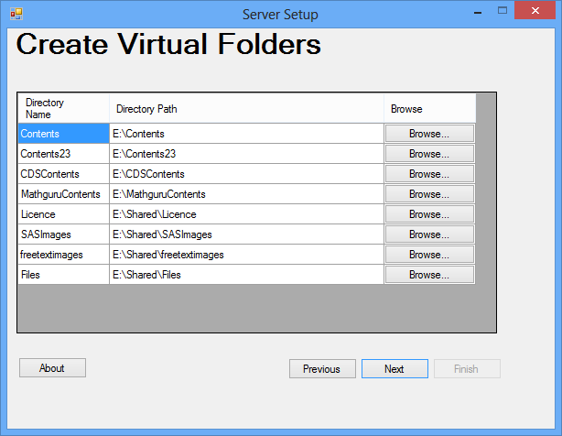
- To Create Virtual Folders browse the physical path of all types of contents and click on next
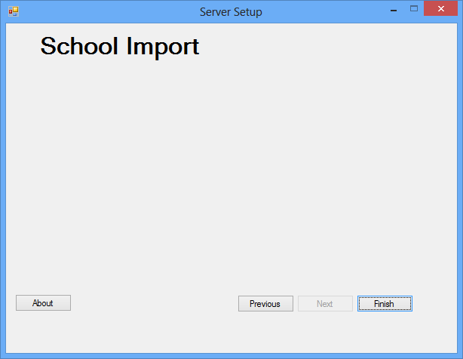
- Click on Finish. A popup with the message Configuration Complete will appear. Click on OK.

Step 9: Installation of Adobe AIR Installer 3.2
Install AdobeAIRInstaller from Supporting Software Folder.
- Double Click on AdobeAIRInstaller File.
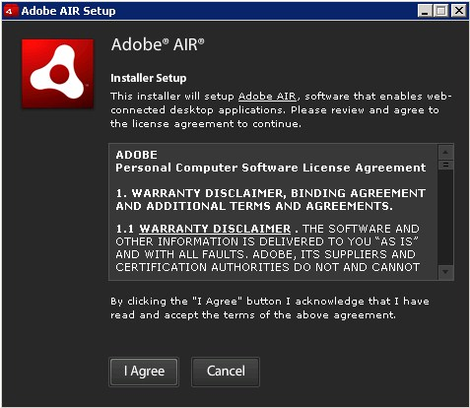
- Click on I Agree Button.
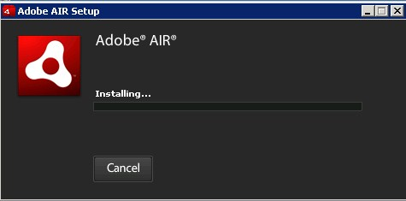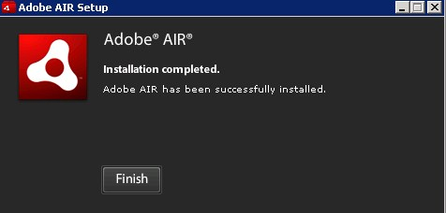

3
.

Click on Finish Button.

Step 10: Install Smartclass CTS.
- Browse the location → ..\ SmartClassCTS Software & Utilites\SmartClassCTS Exe File and run  for installation of Smartclass CTS. After installation, the screen given below will appear.

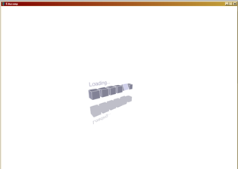
Now please close the screen.

Step 11: Configure Smartclass CTS.
- Change the IP address using..\SmartClassCTS Software & Utilites\CTSIPConfig\CTSIPConfig.exe >>Run As administrator and click on save button to configure. Below screen will appear.

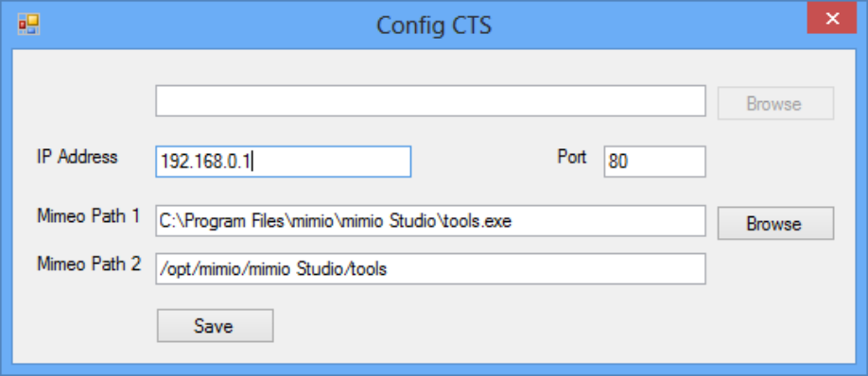
Note no need to change any other values.
Now , double click on CTS icon , smartclassCTS screen should appear as below.
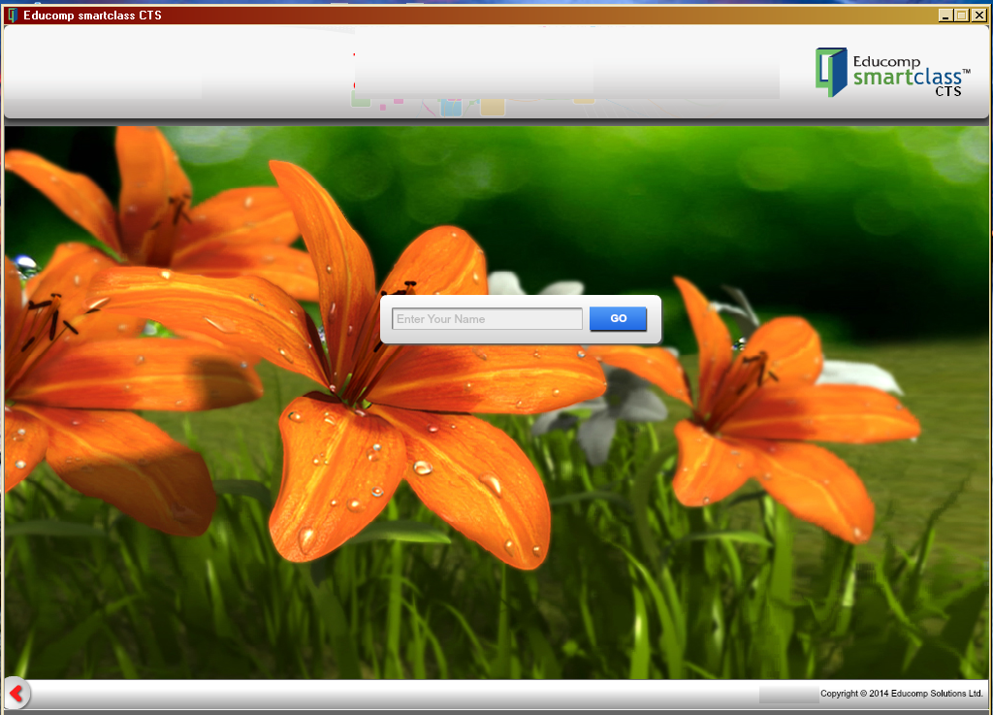

Login ID is: educomp to enter into the system

